

**SCHOOL OF ARCHITECTURE, BUILDING & DESIGN**

Centre for Modern Architecture Studies in Southeast Asia (MASSA)

**Bachelor of Science (Honours) (Architecture)**

**ENVIRONMENTAL SUSTAINABLE DESIGN (ARC 1413/1412)**

***PAYING IT FORWARD***

**Tutor:**

Mr Sanjay

**Organization Proposed:**

Rumah K.I.D.S, USJ 1

**Group Members:**

Tong Chia Sin

Muhammad Haziq bin Ariffin

Lee Min

Feiven Chee

Sonia Alai Mariam Gerawat

Siti Munirah Zazarin

Belinda Mkony

Rick Kong Wen Chee

Farhin Kusairi

Feon Chan Hao Ran

**Table of Contents**

|  |  |
| --- | --- |
| Proposal | *3* |
| Visuals – The Site | *4* |
| **Design process** | |
| Sketches | *5* |
| Digital Rendering | *6* |
| Problems & Solutions | *7* |
| Final Design | *8-9* |
| **Analysis** | |
| Costing Details | *10* |
| Work Schedule | *11* |
| Work Distribution | *12-19* |
| Work Progress | *20-21* |
| Minutes | *22-24* |
| Life Cycle Analysis (LCA) | *25-30* |
| Reflections | *31-35* |

**Proposal**

(1) Rumah K.I.D.S (Kanak-kanak Ini Di Sayangi) opened in 1991, to shelter and rescue displaced children from a life on the streets as well as broken homes. They are taken care of in this house by Sister Gemma and Brother Neil, who are devoted to provide the children with the basic needs, such as food, clothing, shelter and education. Currently, they are taking care of 19 children ranging from 3 – 18 years of age. The finance of the house is completely dependent on donations and therefore many things are left bare and basic, including the garden. (2) We propose to spruce up the garden with more colours and fun elements to create a homely feel for the children. (i) We will use rubber tires and recycled wooden pallets to create a shelter/sitting area. (ii) Finally we will repaint the swings that they currently have as they are rusty and unsafe for the children (tetanus). As the house is located in an urban residential area, the children lack access to playgrounds and a safe environment to play in. (3) We are choosing this project as we feel that it is important to make the house feel more like home for the children and not like an orphanage. Due to this, we will be engaging with the children and ask them to plant the flowers with us. This will also inform the children of the importance of maintaining and caring for the natural environment, as well as show them how we can use recycled materials in a creative way. We will be using rubber tires as they have soft and round edges, making it safe for the children and wooden pallets to create the shelter.

(1) The organization has expressed to us how they would like to recondition the garden to a state that would make the children happy when they see it and possibly discourage the children from going out too often, as it is unsafe. Currently it is quite empty, bare and unsafe. (2) The duration of our project will be a month. (3) We will be working to refurbish the exterior garden area of the house, which is located in Subang Jaya. (4) The main people who will benefit from this project would be the children. They are the people who live in the house, and face the garden everyday. Therefore making it visually nicer and interactive will mean they can enjoy their house more. It will also create awareness of planting and inspire creative thinking on how to reuse unwanted materials. This project will also teach them the values of dedication and commitment as they will have to care for the plants in the long run. (5) The estimated cost for this project will be RM500.00 (6) We will be using rubber tires and wooden pallets as they are used and unwanted, yet have the desirable qualities for this project. We will also be planting many flowers which will create a healthier ecosystem.

**Visuals**

The Site

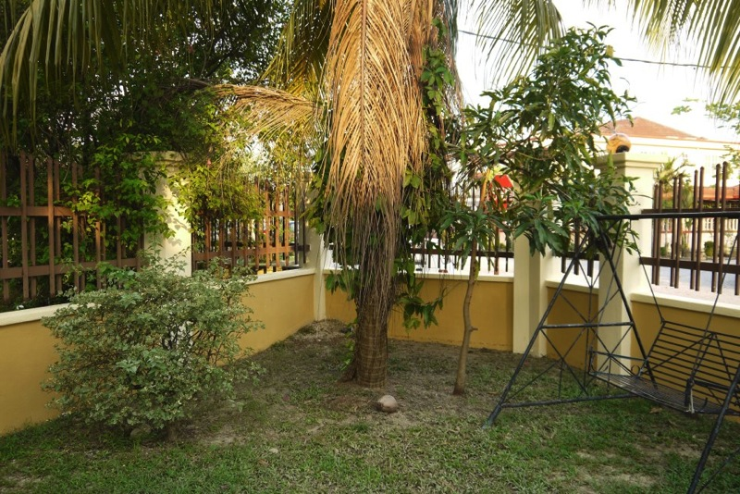

This is the area which we plan to create a shelter using rubber tyres and wooden pallets.

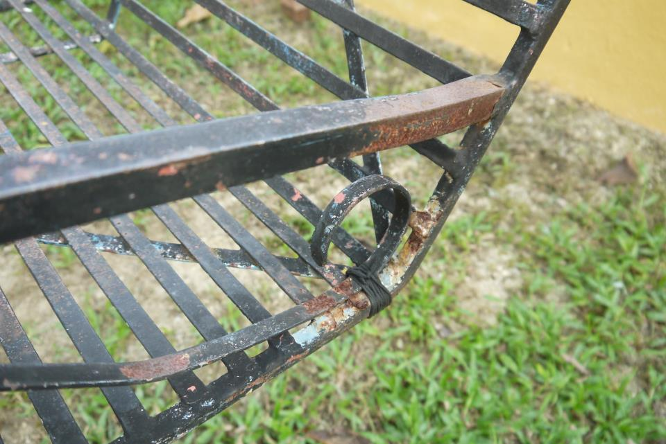

This picture shows the current condition of the swings. They are rusted and dangerous for the children.

**Design Process**

Sketches

These sketches show our design process for the shelter.

|  |  |  |
| --- | --- | --- |
| **1** | D:\Owner\Pictures\2013-06-23\003.jpg | Firstly, we took the site dimensions to figure out how much space we could have to create. This is essential as we are using modular units (tyres and wooden pallets) |
| **2** | D:\Owner\Pictures\2013-06-23\003.jpg | By having the dimensions we could then estimate the amount of tyres we would place for the base. |
| **3** | D:\Owner\Pictures\2013-06-23\002.jpg | We sketched out a rough idea of what we wanted to do with the wooden pallets. |
| **4** | D:\Owner\Pictures\2013-06-23\001.jpg | A sketch to show the relationship between the design and the site context. |
| **5** | D:\Owner\Pictures\2013-06-23\004.jpg | This sketch shows how we plan to join the separate pieces of wood together. |

The following visuals are digital renderings of our initial design.

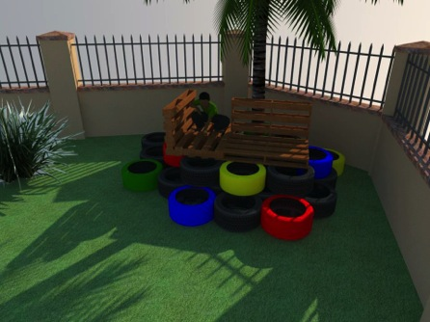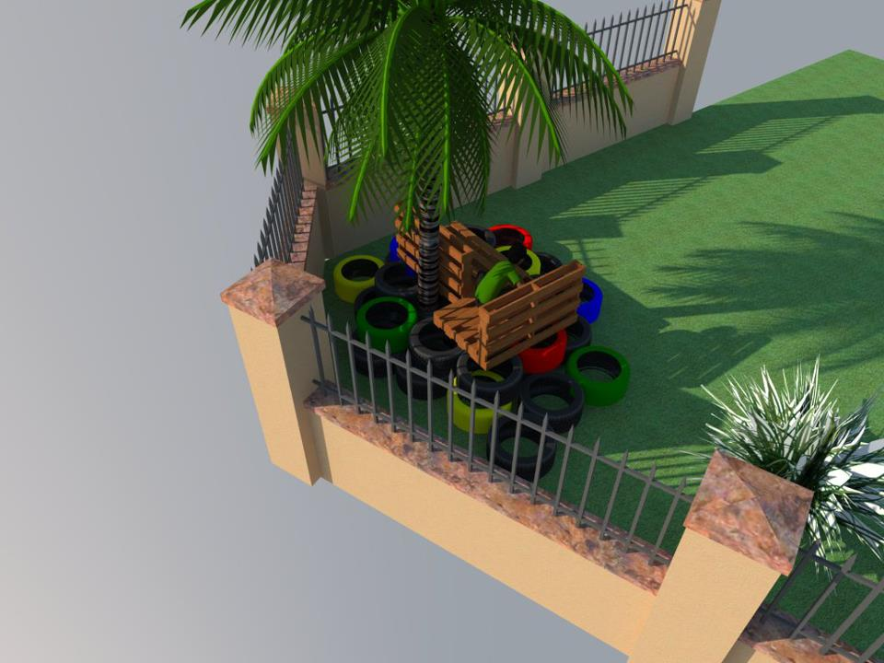

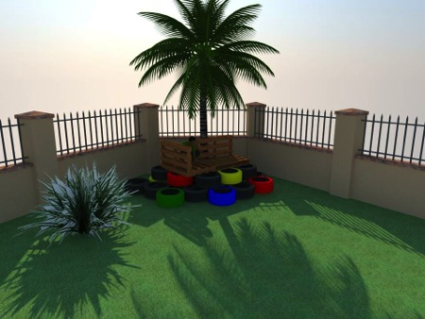

**Problems and Solutions**

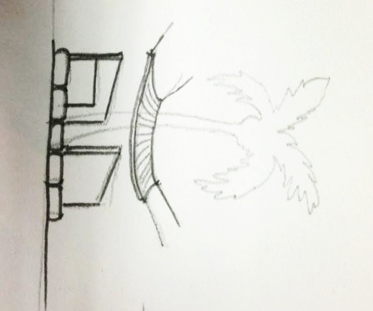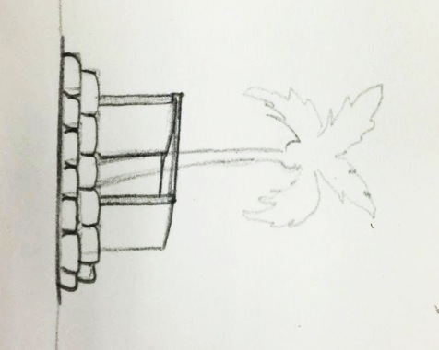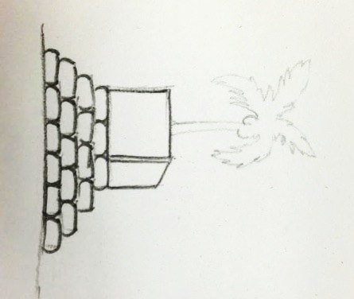

Initial Idea:

Make a roof using wooden pallets

Problem:

Too heavy. Walls cannot support the weight.

Solution:

Stictched up four used bamboo shutters to make a hanging roof. Has aesthetic quality and light-weight.

Initial Idea:

Open deck with no roof.

Problem:

Initially, we did not consider the possibility of coconuts falling from above. Also, more shade is needed

Solution:

Use wooden pallets to make roof.

Initial Idea:

Elevate the shelter by layering the rubber tires to create a something like a “tree house”

Problem:

Rubbers tires sponsored were of different sizes and hence would be unstable if stacked up, and hence would be unstable.

Solution:

Every member agreed to change the design to have only one layer of tires. Still elevated, but safer.

**Final Design**

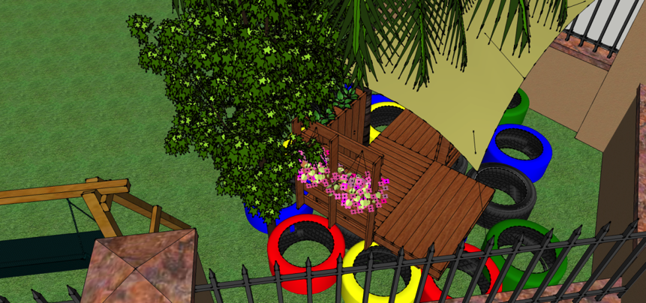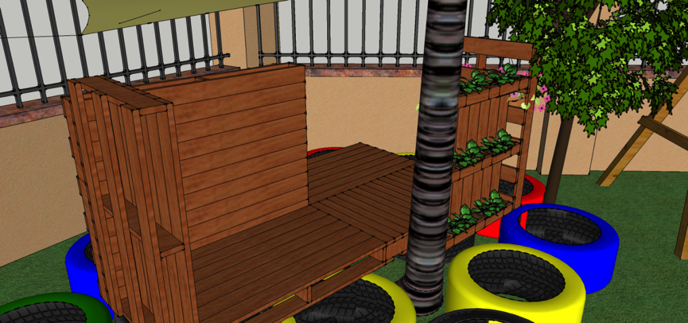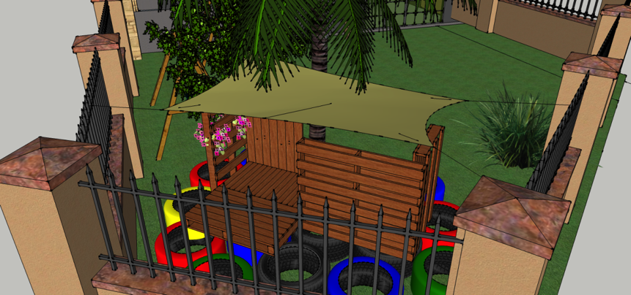

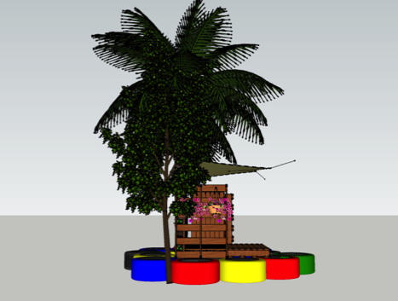 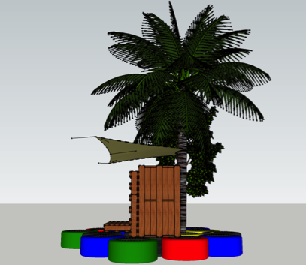

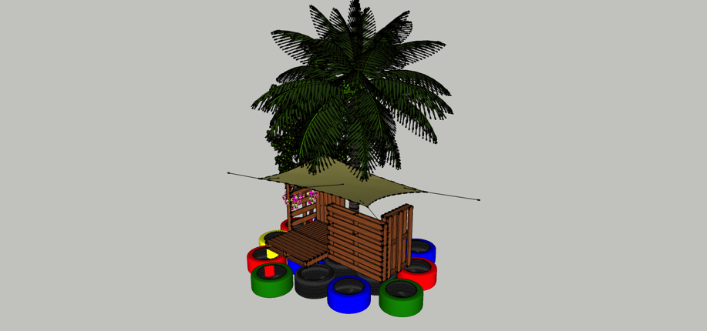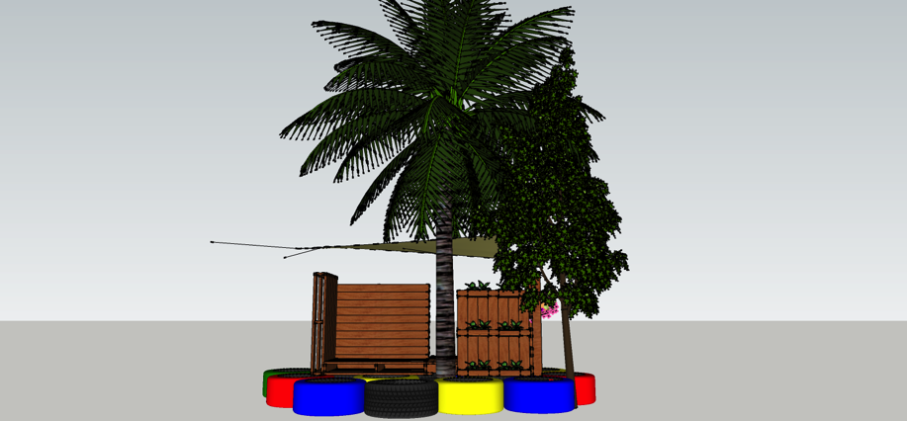

**Costing Details**

This table shows the exact details of our budgeting and expenditure throughout the project.

|  |  |  |  |  |
| --- | --- | --- | --- | --- |
| Ref | Description | Unit Price | QTY | Total |
| 1 | **ICI Dulux Paint** | _ | 4 | _ |
|  | a) Estimated 5 litres paint for 6 tyres |  |  |  |
|  | b) Tyres used : 20 |  |  |  |
|  | * Sponsored by Iklan Chung Leong |  |  |  |
|  |  |  |  |  |
| 2 | **Brushes** | RM4.00 | 6 | RM24.00 |
|  |  |  |  |  |
| 3 | **Nails** | RM0.10 | 30 | RM3.00 |
|  |  |  |  |  |
| 4 | **Flat Bars** (1 inch, 3mm thick) | RM6.00 | 3 | RM18.00 |
|  |  |  |  |  |
| 5 | **Wood Shellacs** (2.5 litres) | RM6.50 | 3 | RM19.50 |
|  |  |  |  |  |
| 6 | **Bamboo Mat** | _ | 4 | _ |
|  | *Recycled material |  |  |  |
|  |  |  |  |  |
| 7 | **Wood Pallets** | _ | 8 | _ |
|  | *Recycled material |  |  |  |
|  |  |  |  |  |
| 8 | **Tyres** | _ | 25 | _ |
|  | *Sponsored by Continental T Tyre |  |  |  |
|  |  |  |  |  |
| 9 | **Strings** (5 metres per roll) | RM2.00 | 1 | RM2.00 |
|  |  |  |  |  |
| 10 | **Sands** (25kgs) | RM6.00 | 40 | RM240.00 |
|  |  |  |  |  |
| 11 | **Potted Plants** |  |  |  |
|  | a) 6-inch pot | RM10.00 | 5 | RM50.00 |
|  | b) 2-inch pot | RM3.00 | 7 | RM21.00 |
|  |  |  |  |  |
| 12 | **Mobilisation** | _ | _ | _ |
|  | *Materials transported by lorry sponsored by |  |  |  |
|  | Iklan Chung Leong |  |  |  |
|  |  |  |  |  |
|  |  |  |  |  |
|  |  |  | Total | RM377.50 |
|  |  |  |  |  |

**KINGSTON:Paying it Forward.pdfWork Schedule**

The following chart shows our planned and actual weekly work progress. Overall, we mostly kept to our schedule except for a disruption when working with the workshop due to prior bookings disabling us from using the workshop at the planned time.

Actual Work Executed

Planned Schedule

**Work Distribution**

Different tasks are allocated to different members of the group as this helps us work more systematically, hence speeding up the process. Some of the more difficult tasks, however, required all of us to be involved. The distribution of work is as follows:

|  |  |  |  |  |
| --- | --- | --- | --- | --- |
| **WEEK** | **TASK** | **PERSON IN CHARGE** | **ADDITIONAL COMMENTS** | **PHOTO** |
| 5 | Designing playground | Rick | Input is given by all members of the group regarding design suggestions, but finalized by one member. |  |
| 6-11 | Taking photos | Chia Sin  Farhin  Sonia  Feon | - | - |
| 6-11 | Recording videos | Sonia  Munirah | - | - |
| 6-11 | Budgeting | Chia Sin | - | - |
| 6 | Unloading tires | All | - | D:\Owner\Downloads\yo1.jpg |
| 6 | Cleaning tires | Feiven  Chia Sin  Farhin  Andy | - | D:\Owner\Downloads\yo4.jpg |
| 6 | Painting tires | Sonia  Haziq  Feon  Rick | - | D:\Owner\Downloads\yo2.jpg |
| 7 | Sourcing for pallets and soil | Feon  Haziq | All members were involved in transporting the pallets. |  |
| 8 | Filling up tires with sand | All | Bricks were used to compact the sand. This increases the tires’ sturdiness, therefore increases safety. They are firmer when stepped on. |  |
| 9 | Disassembling the wooden pallets | | | |
| 10 | No work as workshop is fully booked | | | |
| 11 | Workshop tasks | | | |
| -Sawing | Haziq  Lee Min  Rick | Sawing of the pallets was necessary to suit the dimensions of the site as well as the design. |  |
| -Nailing | Chia Sin  Feiven  Munirah | - |  |
| -Sanding | Belinda  Farhin  Feon | - |  |
|  | -Support | Haziq  Rick  Andy | L-brackets are made from flat bars to support the walls of the shelter. |  |
| 12 | Applying shellac | Chia Sin  Farhin  Belinda  Munirah  Rick | Applying shellac helps increase the durability of the wooden pallets, making the structure more sustainable. |  |
| 12 | Assembling structure | Haziq  Chia Sin  Feon | The structure is assembled at the site itself. |  |
| 12 | Sanding (finishing touches) | All | - |  |
| 12 | Making the roof | Farhin  Andy  Belinda  Sonia  Munirah  Feiven | 4 small used mats made of bamboo sticks are stitched together to create a roof. |  |
| 12 | Attaching the roof | Haziq  Esther  Munirah | - |  |
| 12 | Planting flowers | Lee Min  Farhin  Feiven | Potted flowers are hung onto the pallets. This beautifies it and also teaches the boys to love nature. They are taught to water the plants. |  |
| 12 | Painting swings | All | To maximize the use of materials bought, 2 swings were painted |  |
| 12-13 | Report and video production | Chia Sin  Munirah  Farhin  Sonia  Belinda  Feon  Rick | - | - |

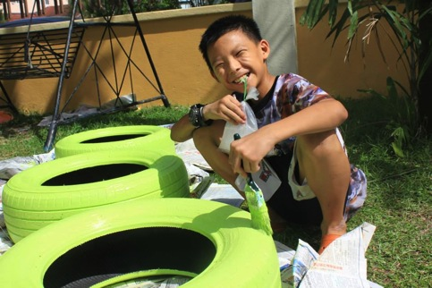When at the site, we were at times assisted by the kids (residents) at the house. Despite not having to ask for their help, they were more than willing to lend us a hand. We found this a very enjoyable experience as it gave us a chance to interact with them.

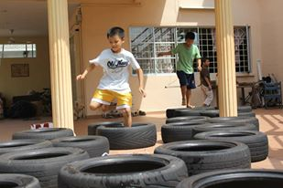

Note: Throughout the project, Sonia will be taking a video of the group’s progress. Munirah will be taking pictures. Rick is in charge of the sitting area/shelter’s design. Feon and Haziq are responsible for sourcing out materials and Chia Sin is in charge of the group’s budget. Feiven and Andy will maintain the overall neatness and cleanliness of the site. Belinda and Farhin will make sure our project can be completed on time, and not fall behind schedule.

**Work Progress**

Week 5: To design the shelter, much was considered, particularly its functionality and safety. All members met up and gave input on how the design should look like, and what material should be used. Other material suggestions included using tires to create the whole playground structure or to use plastic pallets. Wooden pallets were deemed more sustainable, hence was what we went along with. Sketches were made by all members of the group to generate ideas. Once everyone has agreed with the form of the playground, Rick finalized the design by creating visuals of our shelter for our orphanage.

Week 6: Paint is bought a day before work starts on 11th June. We began unloading tires from the truck in the morning. This is followed by the cleaning of the tires to remove dirt/oil before coating it with paint. Two layers of paint were applied. **Work progress is as scheduled (within week 6), however we started work a day later than planned due to other commitments**

Week 7: Feon and Haziq were in charge of sourcing out for wooden pallets. We went to industrial areas and garbage dumps to look for them. Areas nearby (PJS7) were searched first to save time and minimize environmental impact. Though they were highly available, we were selective when choosing the pallets as their condition had to be considered. Only the ones in mint condition were selected. Everyone helped load and transport the pallets to campus. Work progress is still right on track. No delays.

Week 8: Even though it was mid-term break, we still continued working on our project. We started filling in sand into the tires that act as a base to the play area. To make the sand more compact, a brick is added in each tire. This helped increase the strength of the base, at the same time, increasing safety.

Week 9: We disassembled the wooden pallets that needed disassembling. We also removed them of nails and dangerous parts. Nails that were not removable were hammered into the wooden pallets.

Week 10: The carpentry workshop was fully booked due to the SPART Fest. Therefore, there was no work progress for this week apart from doing basic analysis, which did not require the use of the workshop. We made use of our time and thought about ways to assemble the different parts together using metal brackets.

Week 11: It was the first week working in the carpentry workshop. We started sawing, nailing and sanding the wooden pallets. The different tasks were divided among us.

Week 12: We applied shellac on the planks and finally assembled everything on site. Wooden planks were drilled and fixed according to our finalized design. We also connected the bamboo mats with strings, then attached this as a roof to the structure. We started working on video editing and started working on the report. Each member had their own part to do in both the report and the video

Week 13: Report and video completed. Submission week.

**Minutes**

# April 28, 2013

|  |  |
| --- | --- |
| Present: | Everyone |
| *Venue:* | Taylor’s Lakeside Campus |

## Discussion

Discussed about the possible places to visit and time to visit.

Options: P.A.W.S, Agathians Shelter, Rumah Charis, Rumah K.I.D.S

(Time span: 30 minutes)

## Decision

The entire group opted for PAWS. Set a date for site visit on the following day April 29th.

# April 29, 2013

|  |  |
| --- | --- |
| Present: | Everyone |
| *Venue:* | USJ 1/2L, Rumah K.I.D.S |

## Site Visit

Paid for a visit to the site after having classes.

Observation: Site was very unruly, small signboard, poor condition of the roof.

Discussed about how we could contribute to the organization.

(Time span: 1 hour)

## Decision

Make a bigger and clearer signboard for the organization so people are more aware of the place. Clean up the surrounding site. Fix the roof, change fencing of the place.

# May 2, 2013

|  |  |
| --- | --- |
| Present: | Everyone |
| *Venue:* | Taylor’s Lakeside Campus |

## Discussion

The proposal was rejected since the work scope was too small.

Discussed once again about changing to a new site. Rumah K.I.D.S was next on the list as it’s near.

## Site Visit

Went to Rumah K.I.D.S.

Observation: The front yard was bare and had no shade, the swings were old and the paint was wearing off, there weren’t enough plants.

Measured the chosen site. Later, discussed with the guardian and asked for permission.

All of our proposed ideas were approved.

The guardian also, suggested adding more green and decorating the surrounding.

(Time span: 2 hours)

## Proposal

Prepared a new proposal together with the members.

Listed out the tasks that have to be accomplished.

The final proposal is finally approved.

(Time span: 2 hours)

# May 11, 2013

|  |  |
| --- | --- |
| Present: | Everyone |
| *Venue:* | USJ 1/2L, Rumah K.I.D.S |

## Progress

Work starts. Cleaned, painted and arranged the tires.

(Time span: 5 hours)

## Discussion

Discussed where to source for sand, pallets, and when the next meeting is.

Dismissed for the day.

(Time span: 30 minutes)

# May 24, 2013

|  |  |
| --- | --- |
| Present: | Everyone |
| *Venue:* | USJ 1/2L, Rumah K.I.D.S |

## Progress

Putting the wet sand in the painted tires for the base.

Dismissed for the day.

(Time span: 5 hours)

# June 1, 2013

|  |  |
| --- | --- |
| Present: | Everyone |
| *Venue:* | USJ 1/2L, Rumah K.I.D.S |

## Progress

Work starts on pallet by disassembling the wooden pallets. Filling in the tires with the wet sand for the base of the playground.

(Time span: 5 hours)

## Discussion

Booked the carpentry workshop for the woodwork during our free time.

# June 10, 2013

|  |  |
| --- | --- |
| Present: | Everyone |
| *Venue:* | Taylor’s Lakeside Campus Workshop |

## Progress

Using the carpentry workshop to carry out the woodwork.

Sand papering the wooden pallets to prevent rough surfaces, measuring and sawing the wood, drilling holes into the wood for installing L-brackets to support the whole structure.

Dismissed for the day.

(Time span: 7 hours)

*June 18, 2013*

*Present:*  Everyone

*Venue:*  Taylor’s Lakeside Campus Workshop

**I. Progress**

Resumed the rest of the work with all the members.

Touching up the woods with more sanding and painted all of the surfaces with varnish.

Wooden pallets were kept aside to dry up.

Dismissed for the day.

(Time span: 5 hours)

*June 21, 2013*

*Present:* Everyone

*Venue:* Taylor’s Lakeside Campus and Rumah K.I.D.S

**I. Progress**

Gathered the wood pallets and stored them in a van to take to the site.

Each member worked together in different group assembling the pallets.

Nailing the woods together, drilling in screws, sanding the surfaces.

Some were connecting the mats we found at the site with strings for the roofing of the playground.

(Time span: 7 hours)

*June 22, 2013*

*Present:* Everyone

*Venue:* USJ 1/2L, Rumah K.I.D.S

**I. Progress**

Final round to complete the playground and also painting the swings.

Split up into two groups as one handles the playground and the other paints the swings.

Tied the mat for the roof up for the final touch.

**II. Completion**

The playground was ready to be used and the children enjoyed the space.

Cleaned the playground area.

Sat together at the playground and had a group photo taken.

Departed from the site.

(Time span: 4 hours)

**LCA – Life Cycle Analysis**

To assess the sustainability of our design, we have analyzed the life cycle of the respective materials used. A basic life cycle analysis consists of the following aspects:

Since most of the materials used are reused and/or recycled, we are able to reduce the steps involved. The major steps that are looked at are:

* Assembly
* Use
* Disposal

Other aspects such as transportation and how each material is obtained (extraction) are also taken into consideration.

The findings are as follows:

Wooden Pallets

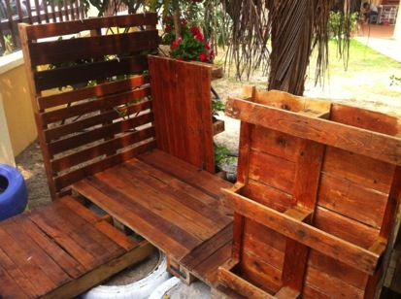

**Extraction/Collecting Pallets**

Since we reused old wooden pallets, environmental impact is reduced as we are not extracting materials from their raw state (trees). This is more environmentally friendly as it reduces energy use – reusing and recycling cuts down on energy use, hence minimizing the carbon footprint produced.

1. 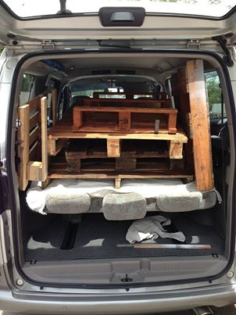**Transportation**

The transportation involved in loading and unloading these pallets only took us 2 car trips: 1. When we collected them and sent them to the workshop, 2. When we brought them to our site at Rumah KIDS. It is worth noting that we have used a multi-purpose vehicle rather than a small car for transportation. This enabled us to save time, reduce energy and at the same time, reduce our carbon footprint.

1. **Assembly**

The assembling of the wooden pallets was done at the site itself. This enabled us to work more systematically and gave us a better picture of the end product (rather than assembling it elsewhere and transporting it to the site).

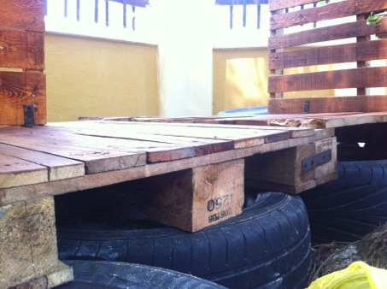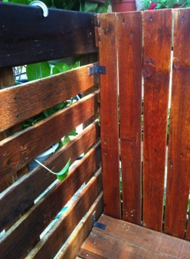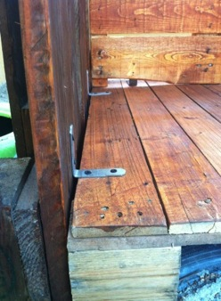

1. 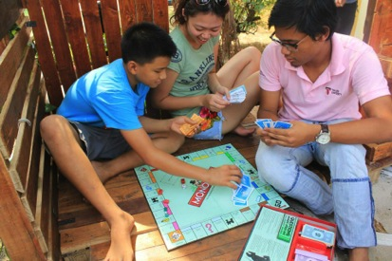**Use**

When using the end product, the environment is not harmed in any way. Instead, it is the complete opposite - it enables the residents of Rumah KIDS to interact with the environment, as well as one another.

1. **Disposal**

To ensure that these pallets are more sustainable, we have coated them with shellac. We hope that this will increase its period of usage. Nevertheless, if the pallets are to be disposed of one day, they can still be reused whether in the same context or for a different purpose altogether. To assemble the pieces together, we have used brackets and screws. In other words, this is a form of ‘design for disassembly’ – the pieces can be taken apart and can be easily reused. This implies that the life cycle of the wooden pallets is never-ending.

In brief, the wooden pallets are an essential choice for environmental sustainability as they are abundant, therefore easily found, are reused materials and are both reusable and recyclable once disposed of. The most energy output occurred during transportation but was very minimal due to a systematic transportation scheme. Other steps of the wooden pallets’ life cycle are not harmful to the environment. They are hence eco-friendly and sustainable.

Rubber Tires

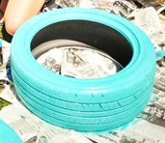

1. **Collection**

The tyres were sponsored by a local company that we have approached. The group was very fortunate to receive the tyres in such good condition which are very suitable and easy to install on the ground as per our project’s planning. There are no visible damage or torn rubber on the surface of the tyre which allows us to paint the tyre smoothly.

1. **Transport**

The used tyres were delivered to site by courtesy of one of the group members who was willing to deliver them with their own vehicle. Therefore, there was no cost involved in the delivery of the material. Once the material arrived at the site, everybody helped to move the tyres from the vehicles to the site. To move the 15 tyres from the pick-up place involved only two trips.

1. **Use**

We painted the tyres with different colours and let them dry. Once the paint has dried, the tyre was installed on the ground as per our design in terms of placement. Before the tyres were installed, we had to clear the debris and level the ground. Once the tyres are placed on the ground neatly, we filled all the tyres with sand, and we compacted the sand with concrete bricks so that the compartment of the tyres are fully filled up with sand. We used it as a one level base for our design. Usage of the tires does not harm the environment in any way.

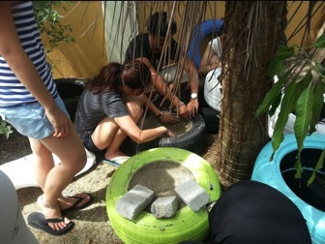

1. **Disposal**

The placement of the tyres is not permanent - they can be easily lifted up after the removal of sand. Therefore, they are easily reused and thus are a good choice for sustainability.

Bamboo Mat

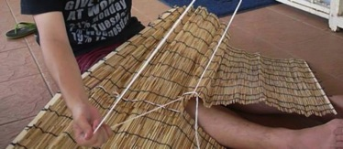

1. **Collection**

The bamboo mat material was found in the house of Rumah K.I.D.S, unused and rolled up. We inquired whether they still needed it and they willingly offered to give it to us for use as a roof. This helped reduce cost, reduce energy output and at the same time, helped us teach the kids regarding the acts of reusing and recycling.

1. **Transport**

As we received the bamboo mat from the house, no transport was needed. Again, this helped minimize negative environmental impact.

1. **Use**

The bamboo mat is used for the roof which acts as shade from the hot sun during the day. We tied three bamboo mats together to form one long structure. We tied long ropes on the ends of the bamboo mat and later tied them on the trees and fences to stabilize the position of the roof.

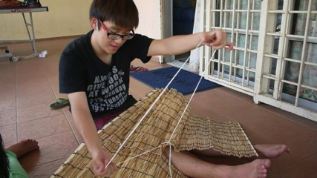 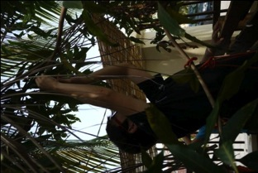

1. **Disposal**

Once the bamboo installation is no longer of use, it can be dismantled piece by piece. They are reusable. To add to that, they are also bio-degradable, hence reduces waste production.

**Reflections**

Tong Chia Sin

The importance of sustainability is highly stressed throughout this project and the idea of using used materials has made me realise how readily available they are, yet their potential was not fully exploited. Through this project, a lot of research was done before proceeding with the work -selection of “sustainable material”

As a group leader, many considerations have to be made regarding our design, cost, materials, and its sustainability. I’m very happy with how proactive everyone is in the group. Heads were put together to come up with ideas for our design and it has made me realize the importance of teamwork, as problem shared is a problem halved.

This project has taught me many things out of the textbook. It was definitely a very healthy exercise and there were many issues faced throughout the journey. However, with every challenge comes experience and it has made me grow in many ways that I could never expect. There is nothing more rewarding than a look of gratitude from the children’s faces and I hope what we did could teach them the importance of taking care of our environment.

Siti Munirah Zazarin

Working on this project has definitely been a rewarding experience. I truly felt that we were ‘paying it forward.’ Not only has it taught us to be better designers; we are also molded into being better people. In other words, it has encouraged us all to become all-rounded individuals. From coming up with the design solution, to working at the workshop together, the variety of skills that we put into application in this project is highly valuable and I am sure, will be applicable in future projects. Also, the knowledge gained regarding the sustainability of different materials has truly opened my eyes – I now understand that it is not only important to be able to design well, but is also equally important to think about the impact of what it is that we are designing. Sustainability is not a trend, they say, but is instead a necessity.

The highlight of working at Rumah KIDS, for me, would definitely have to be interacting with the kids. The smiles on their faces make life as an architecture student a little less stressful. What I will never forget is that when we asked them, “Do you like it?” when enquired about the play area; their answer was a simple, sweet, “Yes.” Nothing could have been more satisfying.

Feiven Chee

Project 2 allowed me to understand the positive impact of sustainable design towards the environment and the community. Our goal was to create an aesthetically pleasing environment for the community by using unwanted materials.

From the selection of materials, preservation of surrounding, to the budgeting of the project, my peers and I had gone through a lot of obstacles throughout this project. Upon the completion of this project, we have learned the importance of staying creative and GREEN even with certain constraints and limitations.

Furthermore, working as a team has allowed us to combine and utilize our skills and talents effectively. As part of a team, I have seen how individual contributions of every group members influence the success of the whole. This project has definitely been benefitial in terms of the experience, knowledge and skills that I have gained along the way.

Lee Min  
I’m really glad and happy to work on this assignment together with my peers at USJ 1, Rumah K.I.D.S. Throughout the processess, I’ve learnt the function and method on how to deal with the relationship between environmental sustainable issues and human interaction especially children. To go eco-friendly, we have decided to put effort in reusing recycled materials such as tyres, wooden pallets and bamboo mats. I really enjoy constructing the sitting area with the children’s additional aids. The best part is that we were able to teach the children about environment awareness.

Belinda Mkony

Every action that contributes to better sustainability is helpful no matter how unimportant it may seem. Project 2 has allowed me to understand the use of sustainable building materials. The project allowed us to be humble by working for an orphanage and knowing that at the end of the day, we are going to leave the site with more value. By doing so the group worked hand in hand with another to achieve a sustainable solution on the site. We were able to construct a safe haven that could be used by anyone at the orphanage. This made me proud because I knew I was making a difference. Sustainability can reduce the harmful impact of human activities on the environment and conserve natural resources; however, in the end it all depends on the people and the willingness to be part of the efforts to leave the future generations an “inhabitable” planet. I believe we left an impact by the selection of materials we used and also by teaching them how simple it is to conserve their space. My peers and I left this project with great knowledge on how to work with one another adding value to materials that did not have worth and were close to disposal.

Rick Kong Wen Chee

Working in this project 2 has allowed me to understand the integration of building materials that are sustainable into the built environment. It also gives me the opportunity to work as a team with my group members that are always willing to help each other as well as conducting material costing study before proceeding to the construction process. The pros of this task are the benefits of experience gained along the process be it on site or off site. The knowledge gained, will be very useful in my future profession as an architect. Usage of recycled materials allow us to reduce the amount of rubbish sent to landfill, save energy and raw materials as well as help tackle climate changes. It also provide materials in low costs that are helpful especially to the less fortunate in the society.

Sonia Alai Mariam Gerawat

First of all, I am grateful to be given the opportunity to serve the community. After accomplishing project 2, I have gained more knowledge, skills, and experience in creating a sustainable design that has a positive impact towards the environment and the community. This project has taught me to work with others as a team in overcoming obstacles throughout the project. Such as, managing the costs of the materials, time, and the material resources. Also, having a work rotation ensures every one of us becomes productive and reduces the risk of collusion between individuals. Besides that, my awareness towards the environment has amplified as little things such as taking in consideration of materials used can make a big difference.

As a group we made an effort in using as much as organic and reusable materials for our design whilst being eco friendly. It is very important to preserve the environment and understand how it can affect us all if we don’t act upon it. Moreover, the best part was being able to work together with the children and seeing them enjoying in sharing the experience with us. My group mates and I are beyond delighted upon the completion of this project knowing that we have put smiles on the children’s faces.

Farhin Kusairi

As a student of architecture, I learn to appreciate and preserve the environment by choosing the right material to specify with the cost constraint and other limitations given, to produce something that will benefit the end users and the society at large in the future. Learning pros and cons along the way, hands on, while gaining some labor work experience. This project is a way of training our young minds to think green while being creative, productive and reliable.

Taking account of the surroundings and environment while helping others in need to enjoy and appreciate it, while doing it in a creative way brings challenge and fun through the hard time-consuming process. Learning to work together as a team, also brings a different sense of satisfaction as it brings us closer together.

We need to appreciate the environment more, thus, we need to be aware and start early for our future in helping in our own way to conserve it and not be a cause of its destruction. By doing this project, we, and hope that others who see it too would realize the importance of preservation by utilizing used materials to improve ones’ surrounding rather than throw them away to contaminate our landfills. It could also save a lot of cost. We also contributed in an effort to reduce carbon footprint by not cutting more valuable resources such as timber that consume CO2 and produce O2 for mankind’s benefit.

Muhammad Haziq bin Ariffin

This project has definitely been one full of excitement, challenges and eye-opening experiences. It has made me realize two important things: there are always people in need of help, kindness and generosity of strangers and that unwanted materials that can be found as scrap can actually be used for a design. This project has pushed my creativity, enhanced my skills in working others and most importantly to manage my time properly. It is a relatively large scale project for an architecture student to embark and pursue, especially running for 8 weeks, therefore time management is perhaps the most important factor in completing this project successfully.

Secondly, working at an orphanage has been rewarding. In addition to my love for children, it has been great knowing that we can inspire them and teach them about the possibilities when a harmony between eco-friendliness and creativity is reached.

Lastly, building the shelter itself was technically challenging. We had to think critically about the structure and whether it would be safe for the children. We had to devise our own joint methods, and although this was difficult I have certainly learnt a lot about structures.

Feon Chan Hao Ran

In this project, team work come first. I’ve learnt about how to care for others and also the environment. As a human being, we should care for our environment. As an architecture student, we need to solve all the issues and come out with some good suggestion. What is a concept in architecture? The main issue will be our concept. We learn about how to make a space more sustainable by applying different theory of this subject. Overall, Environment Sustainable Design is a subject which teach us and give us the basic idea of the environment we are facing now. Air polluted, noise pollution, water pollution, animals dying and etc. We need to think before we do. Do not pollute the earth like others do.

**References**

Overview of Life-cycle assessment [Online], Available: <http://www.solidworks.com/sustainability/life-cycle-assessment.htm>

Maxxis Tire Production Flow Chart [Online], Available:

<http://www.docstoc.com/docs/36507098/Maxxis-Tire-Production-Flow-Chart>

Manufacturing Bamboo Mats [Online], Available:

<http://www.google.com/patents/US8206542>

Sustainable Utilization [Online], Available:

<http://14.160.53.106/NTFP/section5_3.htm>

